



Implement Dijkstra’s algorithm and analyse its performance
LAB MANUAL

Disclaimer: The content is curated from online/offline resources and used for educational purpose only
Implement Dijkstra’s algorithm and analyze its performance with different priority queue implementations.

Objective:
To implement Dijkstra’s algorithm for finding the shortest path in a weighted graph and analyze its performance using different priority queue implementations (e.g., list-based and heap-based).
Problem Statement:
Implement Dijkstra’s algorithm using two types of priority queues: a list and a heap. Analyze and compare their runtime performance using test graphs.

Equipment Required:
- Python installed with Jupyter Notebook
- Libraries: `heapq`, `time`, `matplotlib`
Prerequisites:
- Basic understanding of graphs and shortest path algorithms
- Familiarity with Python programming
- Knowledge of priority queues and their time complexities
Procedure:
Step 1: Import Required Libraries
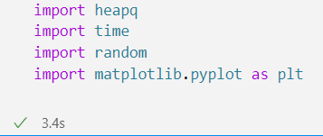

Step 2: Graph Representation
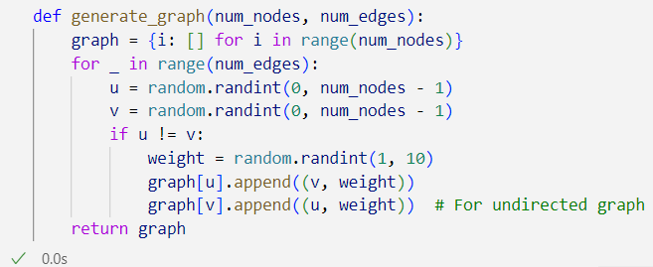

Step 3: Dijkstra’s Algorithm with List-Based Priority Queue
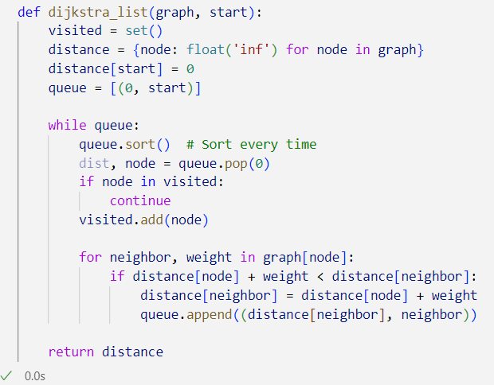

Step 4: Dijkstra’s Algorithm with Heap-Based Priority Queue
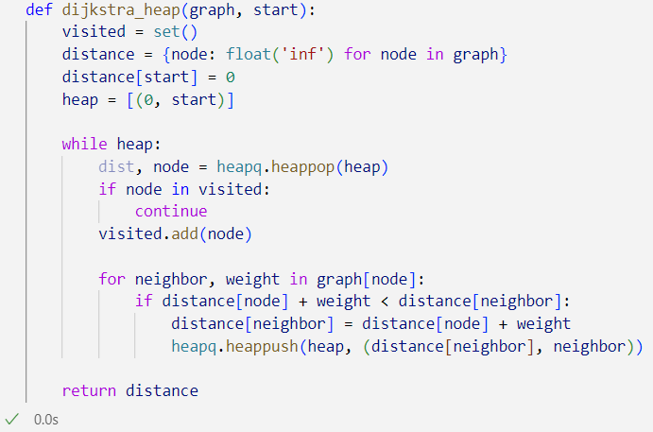

Step 5: Display Dijkstra’s Output
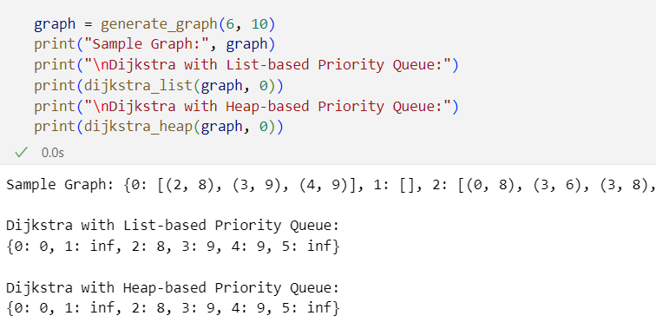

Step 6: Performance Analysis
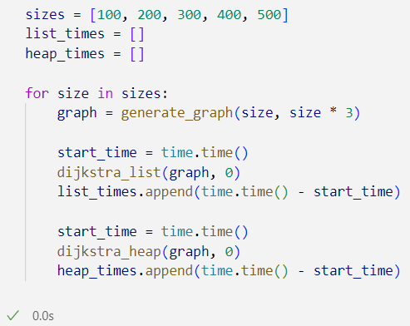
Step 7: Plotting the Results
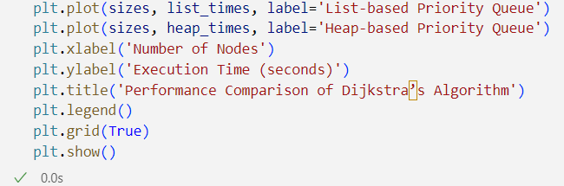

Output:
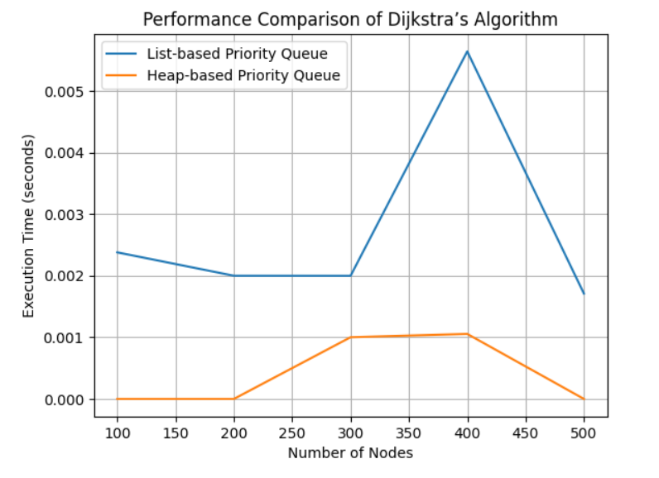

Conclusion
This lab demonstrates the significance of data structure choices in algorithm performance. Heap-based priority queues outperform list-based ones, especially on larger graphs, due to better time complexity for insertion and extraction.

